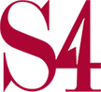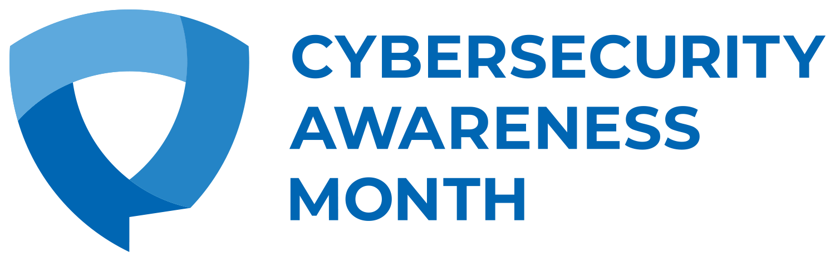

S4 Inc. Announces Commitment to Growing Global Cybersecurity Success by Becoming a Cybersecurity Awareness Month 2022 Champion
Building on annual success Cybersecurity Awareness Month 2022 is set to highlight the growing importance of cybersecurity in our daily lives and look to empower everyday individuals and business to take cybersecurity steps by making cyber more accessible

October 4, 2022 — S4 Inc. today announced that it has signed on as Champion for Cybersecurity Awareness Month 2022. Founded in 2004, Cybersecurity Awareness Month, held each October, is the world’s foremost initiative aimed at promoting cybersecurity awareness and best practices. The Cybersecurity Awareness Month Champions Program is a collaborative effort among businesses, government agencies, colleges and universities, associations, nonprofit organizations and individuals committed to the educating others on online safety.

From mobile to connected home devices, technology is becoming more intertwined with our lives everyday. And while the evolution of technology is moving at the speed of sound, cybercriminals are working just as hard to find ways to compromise technology and disrupt personal and business life. Cybersecurity Awareness Month aims to highlight some of the emerging challenges that exist in the world of cybersecurity today and provide straightforward actionable guidance that anyone can follow to create a safe and secure digital world for themselves and their loved ones.

This year, the Cybersecurity Awareness Month’s main focal areas revolve around four key fundamental cybersecurity best practices:
- Recognizing and reporting phishing – still one of the primary threat actions used by cybercriminals today.
- Understanding the benefits of using a password manager and dispelling existing myths around password manager security and ease of use.
- Enabling multi-factor authentication on personal devices and business networks.
- Installing updates on a regular basis and turning on automated updates.

Now in its 19th year, Cybersecurity Awareness Month continues to build momentum and impact with the ultimate goal of providing everyone with the information they need to stay safer and more secure online. S4 Inc. is proud to support this far-reaching online safety awareness and education initiative which is co-led by the National Cyber Security Alliance and the Cybersecurity and Infrastructure Agency (CISA) of the U.S. Department of Homeland Security.

For more information about Cybersecurity Awareness Month 2022 and how to participate in a wide variety of activities, visit staysafeonline.org/cybersecurity-awareness-month/. You can also follow and use the official hashtag #BeCyberSmart on social media throughout the month.

About S4 Inc.
S4 Inc. is a defense contractor specializing in Enterprise Information Technology Services, Cybersecurity and Professional Services. Since 1999, S4 has provided responsive, mission critical support to Department of Defense (DoD), Department of Homeland Security (DHS) and US Government customers. We deliver efficient and effective solutions to both peacetime planners and war fighters within scope, on time and in budget. S4 Inc. is a small disadvantaged business (SDB) with the agility, strategy, and insight to meet or exceed rapidly changing requirements. Headquartered in Bedford, MA, S4 has offices in Ashburn, VA, Colorado Springs, CO, Dayton, OH, Huntsville, AL, and Omaha, NE as well as several project sites across the United States. S4 Inc. is committed to quality and been ISO 9001 certified since 2007. We currently hold ISO 9001:2015, ISO 27001:2013 and ISO/IEC 20000-1:2018 certifications.

For more information about S4 Inc., please visit www.s4inc.com.

About Cybersecurity Awareness Month
Cybersecurity Awareness Month is designed to engage and educate public- and private-sector partners through events and initiatives with the goal of raising awareness about cybersecurity to increase the resiliency of the nation in the event of a cyber incident. Since the Presidential proclamation establishing Cybersecurity Awareness Month in 2004, the initiative has been formally recognized by Congress, federal, state and local governments and leaders from industry and academia. This united effort is necessary to maintain a cyberspace that is safer and more resilient and remains a source of tremendous opportunity and growth for years to come. For more information, visit staysafeonline.org/cybersecurity-awareness-month/

About National Cybersecurity Alliance
The National Cybersecurity Alliance is a non-profit organization on a mission to create a more secure, interconnected world. We advocate for the safe use of all technology and educate everyone on how best to protect ourselves, our families, and our organizations from cybercrime. We create strong partnerships between governments and corporations to amplify our message and to foster a greater “digital” good. National Cybersecurity Alliance’s core efforts include Cybersecurity Awareness Month (October); Data Privacy Week (Jan. 24-28th); and CyberSecure My Business™, which offers webinars, web resources and workshops to help businesses be resistant to and resilient from cyberattacks. For more information, please visit https://staysafeonline.org.

